Grade 7 Accelerated · Unit 6 · Practice Test  Relationships in Triangles  18 points | Name__________________  Date__________________  Period________________

Show your work. One point for each lettered part.
Part 1. Triangle Inequality and the Converse 3 points
1. Which set of side lengths can form a triangle? 1 pt
○ A. 4 cm, 7 cm, 11 cm
○ B. 12 cm, 5 cm, 6 cm
○ C. 6 cm, 8 cm, 13 cm
○ D. 3 cm, 10 cm, 15 cm

2. Select ALL of the sets of side lengths that make a right triangle. 1 pt
□ A. 17, 8, 15
□ B. 5, 6, 7
□ C. 20, 21, 29
□ D. 7, 24, 26
□ E. 4, 6, 8

3. Two sides of a triangle are 6 inches and 15 inches long. Which inequality shows every possible length x, in inches, of the third side? 1 pt
○ A. 
○ B. 
○ C. 
○ D. 

Part 2. The Pythagorean Theorem 6 points
If an earlier part is wrong, a later part still earns its point when the right operation is applied to your own earlier answer — but only if that work is on the page.
4. Find the missing side of each right triangle.
a. Its legs are 9 inches and 12 inches. How long is the hypotenuse? 1 pt

b. Its hypotenuse is 61 meters and one leg is 60 meters. How long is the other leg? 1 pt

5. A right triangle has legs of 7 centimeters and 13 centimeters. How long is the hypotenuse, in centimeters? Round your answer to the nearest tenth. 1 pt

6. Which equation can be used to find x? 1 pt
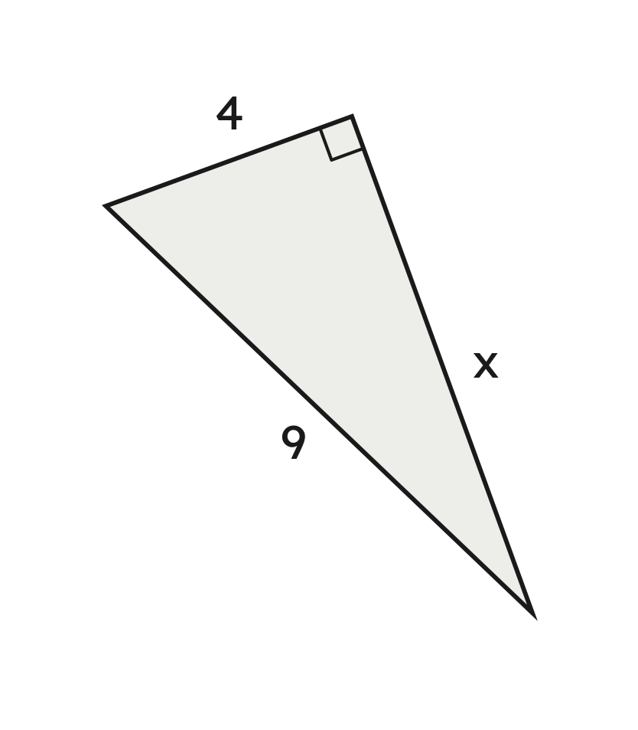
○ A. 4 + x = 9
○ B. 
○ C. 
○ D. 

7. A rectangular garden measures 9 meters by 10 meters. A path runs straight across it from one corner to the opposite corner.
a. How long is the path, in meters? Round your answer to the nearest tenth. 1 pt

b. How much shorter is the path than walking along two sides of the garden? Round your answer to the nearest tenth. 1 pt

Part 3. Distance on the Coordinate Plane 6 points
If an earlier part is wrong, a later part still earns its point when the right operation is applied to your own earlier answer — but only if that work is on the page.
8. Find the distance between points A and B. 1 pt
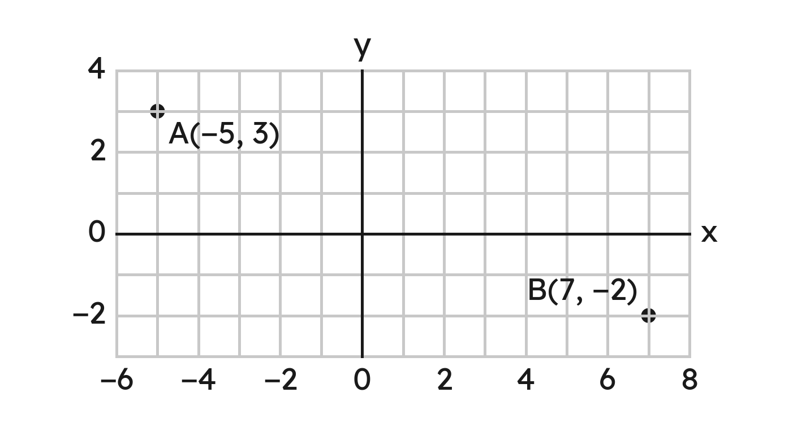

9. Find the distance between (−1, 3) and (4, 1). Round your answer to the nearest tenth. 1 pt

10. Triangle JKL has corners J(−6, 1), K(8, 1) and L(8, 6).
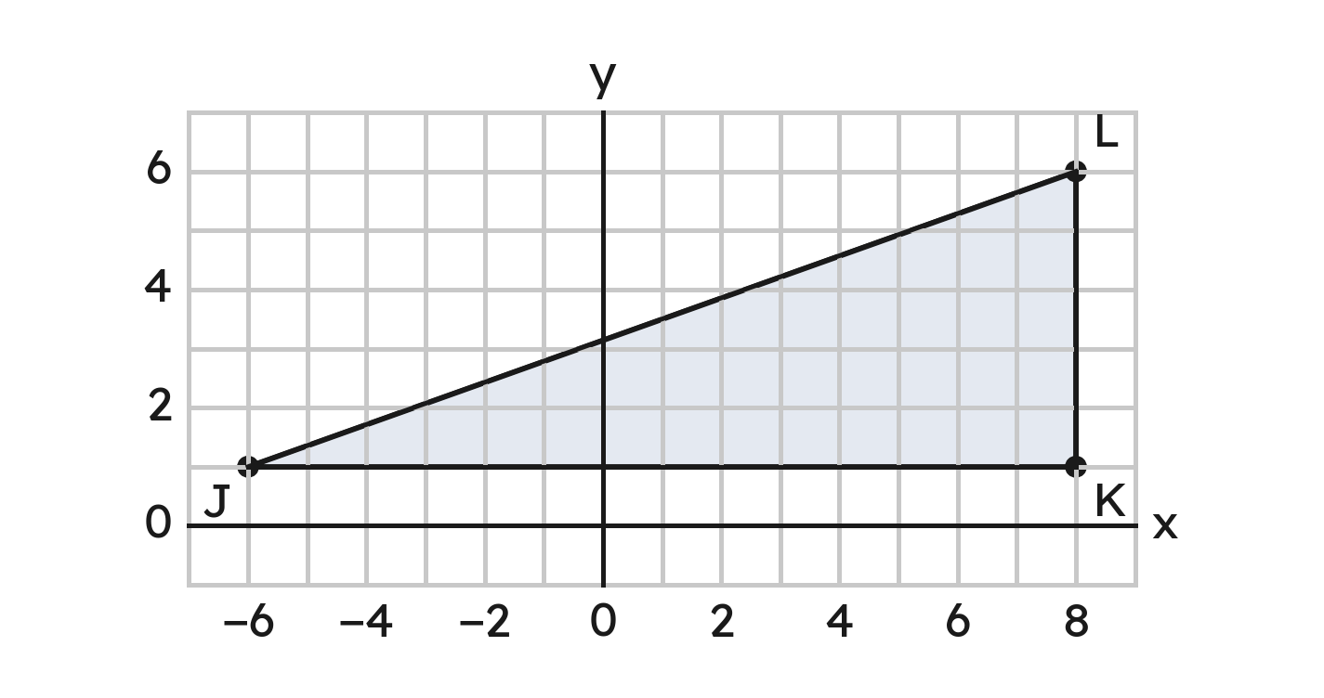
a. Find the length of side JK. 1 pt

b. Find the perimeter of triangle JKL. Round your answer to the nearest tenth. 1 pt

11. On a town map, each unit is one block. The library is at (−1, −5) and the pool is at (8, 7).
a. How far is it from the library to the pool along the streets? 1 pt

b. How far is it in a straight line? 1 pt

Part 4. Similar Triangles 3 points
12. Triangle ABC is similar to triangle DEF. Find x. 1 pt
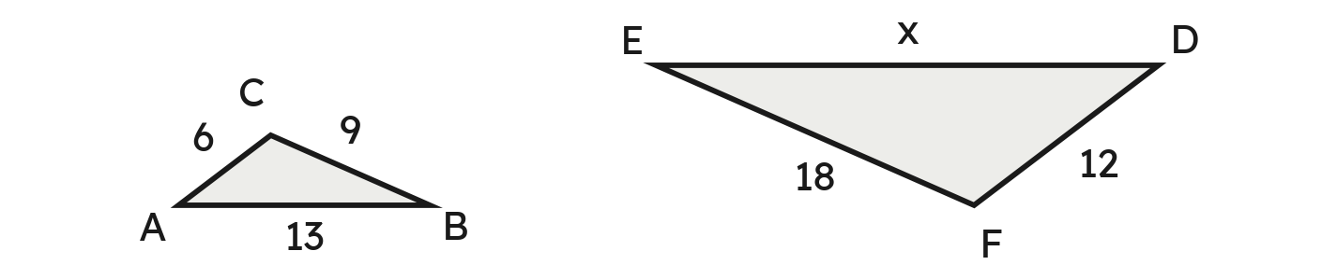

13. A boy 4 ft tall casts a shadow 5 ft long. At the same moment, a tree casts a shadow 30 ft long. How tall is the tree? 1 pt
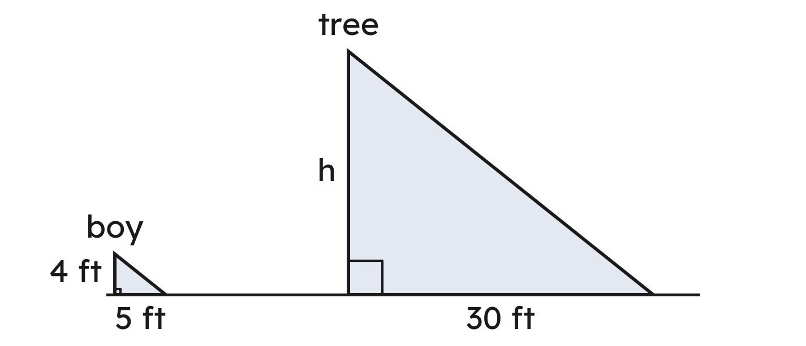

14. Which triangle is similar to a triangle with sides 6, 7 and 10? 1 pt
○ A. 12, 14, 20
○ B. 10, 11, 14
○ C. 12, 14, 18
○ D. 6, 7, 12

